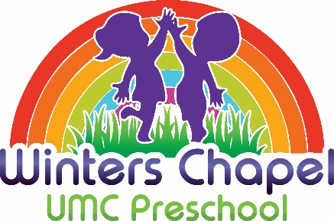
Registration for 2023/2024 School Year Begins on Monday, January 9, 2023 for our currently enrolled students/families. We will open registration to the public on Tuesday, January 10, 2023.
2023/2024 School Year Pricing
PreK (Mon-Fri) $400/month
3’s Program (Mon – Fri) $380/month
3’s Program (Mon – Th) $340/month
3’s Program (T, W, Th) $300/month
2’s Program (Mon – Fri) $380/month
2’s Program (Mon – Th) $340/month
2’s Program (T, W, Th) $300/month
Toddlers (9 – 24mo) (Tu/Th) $280/month
- All classes meet 9am – 1pm
- Tuition includes all activity fees. Student must be the age of class selected by September 1, 2023.
- There is a $110 Registration Fee and a $100 Supply Fee per student.
- The school year tuition has been broken up into 9 equal monthly payments for your convenience.
- Before (8:00am) and After (1:00pm) care programs are available (2:00pm pick up) for an additional fee.
- 20% discount for 2nd child or more per family

